‘From Wasteland to Wetland’ - A History of Woolston Eyes
As many of you will know Brian Martin has been writing a history of the Woolston Eyes Reserve, and we are pleased to announce that this 212-page book it is now published.
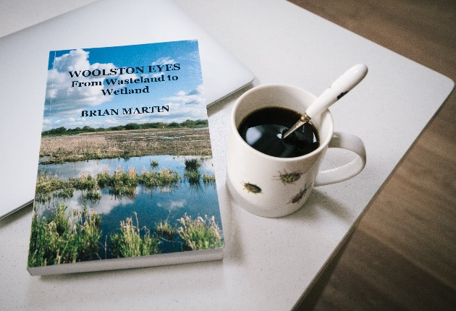
Brian’s book outlines the history of the Woolston Eyes Conservation Group from its earliest days in the 1980s and its trials and triumphs as it created, with the help of the landowners and other partners, one of the foremost wetlands in the country.
Local photographers have contributed many great pictures and there are also papers on some of the most important aspects of the Eyes’ natural history.
There will be a drop-in event to launch the book on Saturday, 4th November when it will be available at a special price of £20. Payment on the day may be made by card machine or cash.
The venue is Grappenhall Community Library, at the junction of Victoria Avenue and Albert Road, Grappenhall, Warrington, WA4 2PE / WA4 2PF, from 2.30 to 4.30 pm.
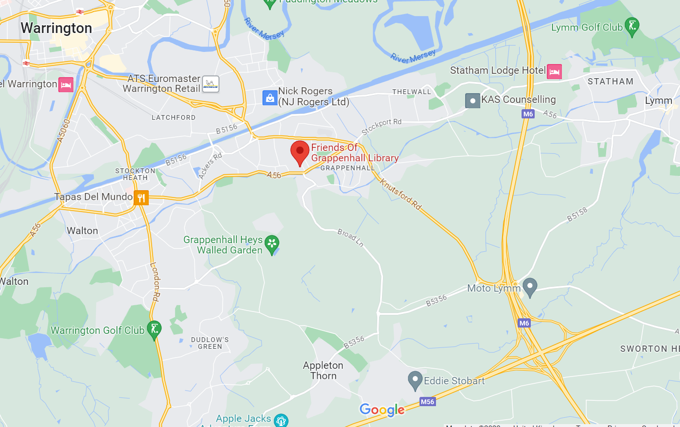
Apart from the afternoon of 4th November, the book will cost £25 plus £3 postage and packing. To order on-line at the full price either before or after the launch please click on the link
Order Form - A History of Woolston Eyes (google.com)

